MINISTRY OF EDUCATION AND SCIENCE OF UKRAINE
NATIONAL TECHNICAL UNIVERSITY OF UKRAINE
"KYIV POLYTECHNICAL INSTITUTE Igor Sikorsky »

APPROVED

Academic Council of KPI. Igor Sikorsky

(Minutes № ___ from "___" _____ 20___)

Chairman of the Academic Council
____________ Mykhailo ILCHENKO

Engineering design tool systems
Scientific and educational program
second (master's) level of higher education

in specialty 131 Applied Mechanics
knowledge Areas 13 Mechanical Engineering
qualification Master of Applied Mechanics

Entered into force in 2021/2022. year
By order of the rector
KPI Igor Sikorsky
from "___" _______20__, № _____

Kyiv– 2021р

HEADLINE
DEVELOPED by the project team:
Project team leader:
Okhrimenko Alexander Anatolyevich, prof. kaf. Machine design, Ph.D., Assoc.

Project team members:
Danilchenko Yuriy Mykhailovych, head kaf. Machine design, Ph.D., prof.
Pasichnyk Vitaliy Anatoliyovych, prof. kaf. Machine design, Ph.D., prof.
Mayboroda Victor Stanislavovich, prof. kaf. Machine design, Ph.D., prof.

For the preparation of food safety education for the lighting program, the head of the Department of Machine Design

AGREED:
Scientific and Methodological Commission of the University in the specialty 131 Applied Mechanics
(Minutes № ___ from "___" ________ 20___)
Chairman of the NMCU 131
___________ Mykola BOBIR

Methodical council of KPI named after Igor Sikorsky
Chairman of the Methodical Council ___________ Yuriy YAKYMENKO
(Minutes № ___ from "___" ________ 20___)

INSURED:
Suggestions, reviews, suggestions of stakeholders, recommendations of professional associations too.
Recommendations for updating the educational and scientific programs at the call:
- with the re-distribution of ECTS credits and components of educational and scientific programs;
- in the change of the National framework of qualifications (Resolution of the Cabinet of Ministries of Ukraine dated 25 April 2020, No. 519).
- Subject to NON / 18/2021 from 01.02.2021 "About the organization and planning of the lighting process for 2021-2022 in the beginning of the day"
The program has been discussed and approved for all the suggestions and suggestions praised by the extended department of Machine Design (Minutes No. 10, 14 June 2021)

LIST OF CONTENTS
- Profile of the educational program
- List of components of the educational program
- Structural and logical scheme of the educational program
- Form of certification of applicants for higher education
- Matrix of correspondence of program competences to components of the educational program
- Matrix for providing program learning outcomes with relevant components of the educational program

1. Profile of the educational program
specialty 131 applied mechanics

1 – Information
Full name of the institute / faculty | National Technical University of Ukraine "Kiev Polytechnic Institute of the Name of Igor Sikorsky", Mechanical Engineering Institute
Higher education grade and title of qualification in original language | Degree - Master  Qualification - Master of Applied Mechanics
Official name of the program | Engineering design tool systems
Type of diploma and scope of the educational program | Master's degree, single, 120 credits, term of study 1 year, 9 months
availability of accreditation | Certificate of accreditation of the specialty НД 1192625, valid until 01.07.2023
Higher education level | НРК of Ukraine - level 7, QF-EHEA - second cycle, EQF-LLL - level 7.
prerequisites | Having a bachelor's degree
Language of instruction | Ukrainian
Duration of the educational program | Until the next accreditation
Internet address of the permanent placement of the educational program | http://mmi.kpi.ua/op  http://osvita.kpi.ua
2 – Purpose of the educational program
Training of a specialist who is able to solve complex problems and problems in the field of applied mechanics and mechanical engineering and carry out innovative professional activities in the context of sustainable innovative scientific and technological development of society and the formation of high adaptability of applicants for higher education in the context of the transformation of the labor market through interaction with employers and other stakeholders. To create conditions for the comprehensive professional, intellectual, social and creative development of the individual at the highest levels of excellence in the educational and scientific environment in accordance with the development strategy of KPI Igor Sikorsky for 2020-205 [https://kpi.ua/2020-2025-strategy].
3 – Characteristics of the educational program
Subject area | - object of activity: constructions, machines, equipment, mechanical, biomechanical and mechatronic systems and complexes, the processes of their design, manufacture, research;  - complete guidance: professional engineering and technical base in the field of design, production, technicians and scientific research of technical systems, equipment and equipment;  - theoretical content of the subject area: the laws of mechanics and their applications, design, theoretical foundations of design, analysis of optimal design processes and technology for the production of machines, the basics of organizing and conducting scientific research of machine equipment and mechanical engineering.  - methods, techniques and technologies: analytical and numerical methods for the design and calculation of machines and structures, mathematical and computer modeling of machines and mechanisms; techniques and technologies of technological experience; information technology in engineering research, design and production;  - Tools and equipment: machine tools, tools, technologists and control devices, control and measuring information systems, hardware and software for robotic systems.
Orientation of the educational program | Educational scientific
The main focus of the educational program | Special education in applied mechanics  Key words: structures in mechanical engineering, mechanical engineering technologies, technologies for computer design of equipment and its units, technological preparation of production, design automation in mechanical engineering, instrumental systems in mechanical engineering, technologies and equipment for shaping in mechanical engineering, engineering design
Features of the programs: | The features of the program are determined by the specifics of the subject area, namely, it is aimed at training specialists in applied mechanics based on specialized design and technological training in the field of mechanical engineering, tool production and support, as well as computer training in the design and 3D modeling of complex products and tool systems. , their improvement and optimization and scientific research in this area. Also, the training model is based on the innovative component of solving promising problems and problems of machine-building production in the world market in the areas of a harmonious combination of functional, aesthetic, ergonomic and technical and economic indicators of the designed products. Where is a specialist in this educational program, in a large production he cooperates with an industrial designer and a design engineer, and in small enterprises he is a designer-constructor-technologist who is able to offer an idea of ​​an attractive appearance for a consumer, translate it into a three-dimensional computer model, calculate from the point of view engineering parameters and implement technologies for its effective manufacture.
4 – Suitability of graduates for further education
Suitability of graduates for employment and further study | The specialist is able to perform professional work according to the classifier of professions DK 003: 2010
Further training | Possibility to continue education for the third (educational and scientific) education. You can add additional qualifications in the system of diploma education.
5 – Teaching and estimation
Teaching and learning | The learning style is cognitive-cognitive, which is based on various teaching methods and technologies. Teaching is carried out in the form of: lectures, seminars, practical exercises, laboratory exercises in small groups (up to 8 people), independent work with the possibility of consultation with a teacher, individual lessons, the use of information and communication technologies (e-learning, online lectures, OCW, distance courses) on individual educational components.
Evaluation | The assessment of students' knowledge is carried out in accordance with the provisions of the systems for assessing the results of training at the KPI for all types of classroom and extracurricular work (current, calendar, semester control). Rating system of assessment, credits, individual assessments of coursework, testing, semester certification, work on thesis.
6 – Program competencies
Integral competence | Ability to solve complex problems and problems in applied mechanics or in the learning process, which involves research or innovation and is characterized by uncertainty of conditions and requirements.
General competencies (ЗК)
ЗК 1 | Ability to identify, pose and solve problems.
ЗК 2 | Ability to use information and communication technologies
ЗК 3 | Ability to generate new ideas (creativity)
ЗК 4 | Ability to develop and manage projects
ЗК 5 | Ability to communicate with representatives of other professional groups of different levels (with experts from other fields of knowledge / types of economic activity)
ЗК 6 | Ability to learn and master modern knowledge
ЗК 7 | Ability to conduct research at the appropriate level.
Special (professional) competencies of the specialty (СК)
ФК 1 | Ability to apply appropriate methods and resources of modern engineering to find optimal solutions to a wide range of engineering problems using modern approaches, forecasting methods, information technology and taking into account existing constraints and apply appropriate scientific and technical methods, information technology and applied computer software to solve engineering and scientific problems in applied mechanics, finding the optimal solution in terms of incomplete information and conflicting requirements
ФК 2 | Ability to describe, classify and model a wide range of technical objects and processes, based on a deep knowledge and understanding of theories and practices of mechanical engineering, as well as knowledge of related sciences.
ФК 3 | Ability to work independently and function effectively as a group leader
ФК 4 | The ability to clearly and unambiguously convey their own conclusions, knowledge and explanations to professionals and non-specialists, including in the teaching process
ФК5 | Ability to plan and perform experimental and theoretical research on applied mechanics and related interdisciplinary problems
ФК 6 | Ability to determine the sets of allowable instrumental and technological support of the processes of forming surfaces of parts and reasonably choose the most appropriate for certain operating conditions and apply knowledge of modern methods of use, manufacturing high quality tools, increased reliability, and develop ways to purposefully change the performance of tools at all stages by reasonable use of modern methods of their manufacture taking into account operating conditions and ways of restoration.
ФК 7 | Ability to analyze capabilities and effectively apply modern information technology to support engineering solutions at all stages of the life cycle of the object of engineering design.
ФК 8 | Ability to use methods of additive forming of parts and their hybrid combinations with other types of processing.
ФК 9 | Ability to develop physical and mathematical models of molding processes, to develop methods of experiments, to solve optimization problems in scientific and applied research
7 – Program learning outcomes
РН 1 | To develop and put into production new types of products, in particular to carry out research and development work or to develop technological support of the process of its production
РН 2 | Apply automation systems to perform research, design work, technological training and engineering analysis in mechanical engineering
РН 3 | Perform geometric modeling, static and dynamic analysis of structures, mechanisms, materials and processes at the design stage using modern computer systems, justify their own interpretation of the results based on modern ideas of mechanical engineering and related fields of knowledge
РН 4 | Use modern methods to determine the optimal parameters of technical systems by means of system analysis, mathematical and computer modeling, in particular in terms of incomplete and inconsistent information
РН 5 | Independently set and solve innovative tasks, argue and defend the results and decisions
РН 6 | Develop, implement and evaluate innovative projects taking into account engineering, legal, environmental and social aspects
РН 7 | Clearly and unambiguously present the results of research and projects, communicate their own conclusions, arguments and explanations in state and foreign languages orally and in writing to colleagues, students and representatives of other professional groups of different levels
РН 8 | Learn and master modern knowledge, technologies, tools and methods, in particular through independent study of professional literature, participation in scientific, technical and educational activities
РН 9 | Organize the work of the group in the implementation of tasks, complex projects, research, understand the work of others, give clear instructions
РН 10 | Search for the necessary information in scientific and technical literature, electronic databases and other sources, evaluate and analyze this information
РН 11 | Plan and perform experimental and theoretical research in the field of applied mechanics, analyze their results, substantiate conclusions
РН 12 | To develop effective processes of shaping of surfaces of details of their technological maintenance taking into account features of a life cycle of a product
РН 13 | Develop and design products taking into account the features of modern design and technological support in engineering design
РН 14 | Develop information technologies to support engineering solutions at all stages of the life cycle of an engineering design object
РН 15 | Develop and analyze models of engineering design processes and their supporting molding processes
8 – Resource support for program implementation
Staffing | In accordance with the personnel requirements for ensuring the implementation of educational activities for the relevant level of approved by the Resolution of the Cabinet of Ministers of Ukraine dated 30.12.2015 № 1187 as amended in accordance with the Resolution of the Cabinet of Ministers of Ukraine №347 dated 10.05.2018
Logistics | In accordance with the technological requirements for material and technical support of educational activities of the relevant level of approved by the Resolution of the Cabinet of Ministers of Ukraine dated 30.12.2015 № 1187 as amended in accordance with the Resolution of the Cabinet of Ministers of Ukraine №347 dated 10.05.2018  Use of equipment for lectures in the format of presentations, network technologies, in particular on the Sikorsky distance learning platform.
Information and educational and methodical support | In accordance with the technological requirements for educational and methodological and informational support of educational activities of the relevant level of approved by the Resolution of the Cabinet of Ministers of Ukraine dated 30.12.2015 № 1187 as amended in accordance with the Resolution of the Cabinet of Ministers of Ukraine №347 dated 10.05.2018.  Use of the Scientific and Technical Library of KPI named after Igor Sikorsky
9 – Academic mobility
National credit mobility | The program provides for the possibility of concluding agreements on academic mobility and double graduation
International credit mobility | The program provides for the possibility of concluding agreements on international academic mobility (Erasmus + K1), on double graduation, on long-term international projects that involve the inclusion of students
Training of foreign applicants for higher education | Possibility of teaching in Ukrainian in general training groups or in English with the provision of learning Ukrainian as a foreign language

2. LIST OF COMPONENTS OF THE EDUCATIONAL PROGRAM
Kod | Components of the educational program (academic disciplines, practices, qualification work) | Number of credits | Form of final control
1 | 2 | 3 | 4
1. REGULATORY (MANDATORY) educational components
1.1. General training cycle
ЗО 1 | Intellectual property and patent science | 3 | test
ЗО 2 | Fundamentals of engineering and sustainable development technologies | 2 | test
ЗО 3 | Practical course of foreign language scientific communication | 4,5 | test
ЗО 4 | Project management in science-intensive engineering | 3 | test
ЗО 5 | Mathematical modeling of systems and processes | 4 | exam
ЗО 6 | Modern design methods | 3,5 | test
ЗО 7 | Pedagogy of high school | 2 | test
1.2. Cycle of professional training
ПО 1 | Computer simulation | 6 | exam
ПО 2 | Computer simulation course project | 1,5 | test
ПО 3 | Engineering design tools | 5 | exam
ПО 4 | Additive technologies | 6 | exam
ПО 5 | Design methodology | 4,5 | test
ПО 6 | Dynamics of machining systems | 3 | test
Research (scientific) component
ПО 7 | Scientific work on the topic of master's dissertation | 10 | test
ПО 8 | Research practice | 9 | test
ПО 9 | Completion of a master's thesis | 17 | graduation
- SELECTIVE educational components
ПВ 1 | Educational component 1 of the F-catalog | 6 | test
ПВ 2 | Educational component 2 of the F-catalog | 6 | exam
ПВ 3 | Educational component 3 of the F-catalog | 6 | exam
ПВ 4 | Educational component 4 of the F-catalog | 4 | test
ПВ 5 | Educational component 5 of the F-catalog | 4 | test
ПВ 6 | Educational component 6 of the F-catalog | 5 | exam
ПВ 7 | Educational component 7 of the F-catalog | 5 | exam
The total amount of required components: |  | 84
Total volume of sample components: |  | 36
TOTAL VOLUME OF THE EDUCATIONAL PROGRAM |  | 120

- STRUCTURAL AND LOGICAL SCHEME OF THE EDUCATIONAL PROGRAM
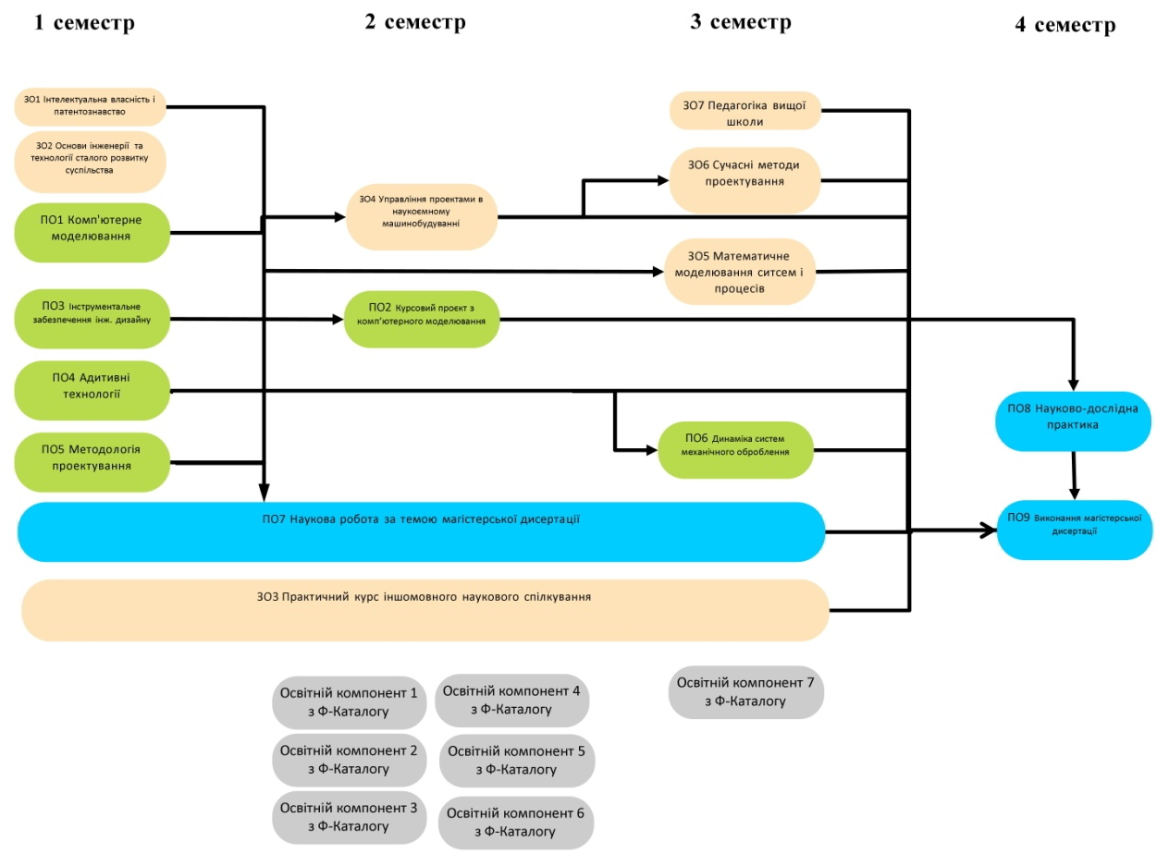

4. FORM OF CERTIFICATION OF HIGHER EDUCATION APPLICANTS
Certification of applicants for higher education in the educational program "Instrumental Systems of Engineering Design" specialty 131 applied Mechanics is carried out in the form of defense of qualification work and ends with the issuance of a document of the established form on awarding him a master's degree with the assignment of a Master of Applied Mechanics qualification. Certification is carried out openly and publicly. The qualification work is checked for plagiarism and, after protection, is placed in the university's repository for free access.

5. MATRIX OF COMPLIANCE OF SOFTWARE COMPETENCIES WITH COMPONENTS OF THE EDUCATIONAL AND SCIENTIFIC PROGRAM
 | ЗО 1 | ЗО 2 | ЗО 3 | ЗО 4 | ЗО 5 | ЗО 6 | ЗО 7 | ПО 1 | ПО 2 | ПО 3 | ПО 4 | ПО 5 | ПО 6 | ПО 7 | ПО 8 | ПО 9
ЗК 1 |  | х |  |  |  |  |  |  |  |  |  |  |  | х |  | х
ЗК 2 |  |  | х |  |  |  | х |  |  |  |  |  |  | х
ЗК 3 | х |  |  |  |  |  |  |  |  |  |  |  |  | х |  | х
ЗК 4 |  |  |  | х |  |  |  |  |  |  |  |  |  |  |  | х
ЗК 5 |  |  | х
ЗК 6 |  |  |  |  |  |  | х |  |  |  |  |  |  | х | х | х
ЗК 7 |  |  |  |  | х | х |  | х |  |  |  | х |  |  |  | х
ФК 1 |  |  |  |  |  |  |  |  |  |  |  | х |  |  |  | х
ФК 2 |  |  |  |  |  |  |  |  |  |  |  |  |  | х |  | х
ФК 3 |  | х |  |  |  |  |  |  |  |  |  |  |  | х | х | х
ФК 4 |  | х |  |  |  |  |  |  |  |  |  |  |  | х |  | х
ФК 5 |  |  |  |  |  |  |  |  |  |  |  |  |  | х |  | х
ФК 6 |  |  |  |  |  |  |  |  |  | х |  |  | х |  |  | х
ФК 7 |  |  |  |  |  |  |  | х | х |  |  |  |  |  |  | х
ФК 8 |  |  |  |  |  |  |  |  |  |  | х |  |  |  |  | х
ФК 9 |  |  |  |  |  |  |  |  |  |  |  | х |  | х |  | х

6. MATRIX OF PROVIDING SOFTWARE LEARNING RESULTS BY RELEVANT COMPONENTS OF THE EDUCATIONAL PROGRAM
 | ЗО 1 | ЗО 2 | ЗО 3 | ЗО 4 | ЗО 5 | ЗО 6 | ЗО 7 | ПО 1 | ПО 2 | ПО 3 | ПО 4 | ПО 5 | ПО 6 | ПО 7 | ПО 8 | ПО 9
РН 1 | х |  |  |  |  |  |  | х | х | х | х | х |  | х
РН 2 |  |  |  |  |  |  |  | х | х |  |  | х
РН 3 |  |  |  |  |  |  |  | х | х |  |  | х |  | х |  | х
РН 4 |  |  |  |  |  | х |  |  |  |  |  | х |  | х |  | х
РН 5 | х | х |  | х |  |  |  |  |  |  |  |  |  | х | х
РН 6 |  | х |  | х |  |  |  |  |  |  |  |  |  | х | х
РН 7 |  |  | х |  |  |  |  |  |  |  |  |  |  | х | х | х
РН 8 |  |  | х |  |  |  |  |  |  |  |  |  |  | х
РН 9 |  |  |  | х |  |  | х |  |  |  |  |  |  | х | х | х
РН 10 | х |  |  |  |  |  |  |  |  |  |  |  |  | х | х | х
РН 11 |  |  |  |  | х |  |  |  |  |  |  |  |  | х
РН 12 |  |  |  |  |  |  |  |  |  | х | х |  |  | х
РН 13 |  |  |  |  |  |  |  | х | х | х | х | х |  | х
РН 14 |  |  |  |  |  |  |  | х | х |  |  |  |  | х
РН 15 |  |  |  |  |  |  |  |  |  | х | х | х | х | х

